**How to Use**

Use npm start on the Command line to launch the app

Listening on port 3000

**Routes**

Home route (“/”)

Has a simple interface with one textbox on top for the username, one dropdown menu for the selection of the search parameter to use, textbox on bottom for the search parameter and one submit button

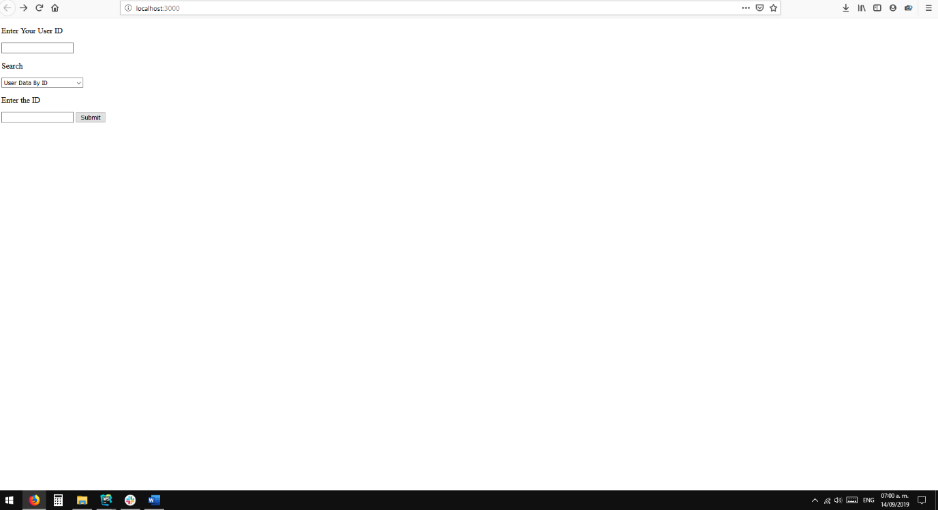

Client route (“/client”)

It will receive two parameters (user_id & id | user_id & user_name) and search the files to find if the query is an acceptable one and return the information of the client searched.

examples of accepted queries:

/client?user_id=a0ece5db-cd14-4f21-812f-966633e7be86&id=e8fd159b-57c4-4d36-9bd7-a59ca13057bb

/client?user_id=0178914c-548b-4a4c-b918-47d6a391530c&user_name=Merrill

Policy route (“/policy”)

It will receive two parameters (user_id & policy_number | user_id & user_name) and search the files to find if the query is an acceptable one and return the information of the client or all the policies linked to the client respectively.

examples of accepted queries:

/client?user_id=ce40de49-241b-46e4-8077-1f455c8bdcdd&policy_number=0eba1179-6155-41b5-bdd8-f80e1ac94cab

/client?user_id=f382dce9-8152-49ba-ba54-9a7f90a8a332&user_name=Britney

**Extra Details**

The API will throw error messages on the following cases:

The user_id is not provided.

The user_id is not on the database.

The user_id role is not the appropriate to look the information.

The search parameter is not provided (id, user_name or policy_number).

Two search parameters are provided at the same time.

The searched parameter is not on the file.

The user searched has no linked policies while using the policies linked route.